Experiment:6 Date:25/07/2026

The Vacuum Cleaner Problem Using Breadth-First Using Search (BFS) Algorithm

AIM:
To develop a Python program to solve the Vacuum Cleaner Problem using the Breadth-First Search (BFS) algorithm by cleaning all dirty rooms and reaching the goal state.

Algorithm (BFS):
- Read the status of Room A and Room B.
- Read the initial position of the vacuum cleaner.
- Store the initial state.
- If the current room is dirty, clean it.
- Otherwise, move to the other room.
- Repeat the process until both rooms are clean.
- Display each step performed.
- Stop when the goal state is reached.

PROGRAM:
roomA = input("Enter Room A Status (Dirty/Clean): ").lower()
roomB = input("Enter Room B Status (Dirty/Clean): ").lower()
pos = input("Enter Vacuum Position (A/B): ").upper()
step = 0
print("\nInitial State")
print("Room A :", roomA)
print("Room B :", roomB)
print("Vacuum :", pos)
while roomA == "dirty" or roomB == "dirty":
step += 1
if pos == "A":
if roomA == "dirty":
roomA = "clean"
print(f"\nStep {step}: Clean Room A")
else:
pos = "B"
print(f"\nStep {step}: Move to Room B")
else:
if roomB == "dirty":
roomB = "clean"
print(f"\nStep {step}: Clean Room B")
else:
pos = "A"
print(f"\nStep {step}: Move to Room A")
print("Room A :", roomA)
print("Room B :", roomB)
print("Vacuum :", pos)
print("\nGoal State Reached")

OUTPUT:
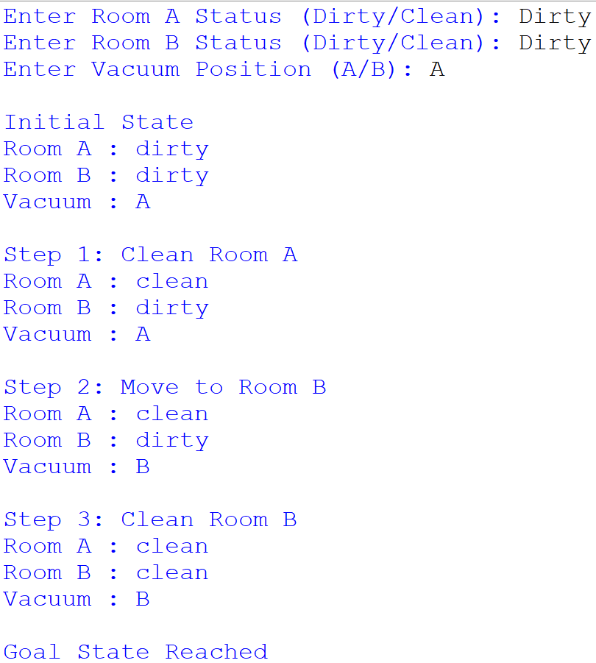
RESULT:
Thus, the Vacuum Cleaner Problem was solved successfully using the Breadth-First Search (BFS) algorithm, and both rooms were cleaned to reach the goal state.

